7. TESTING AND RESULTS
7.1 SAMPLE INPUTS AND OUTPUTS
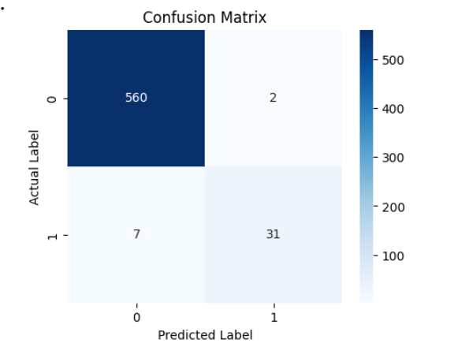
Figure 7.1: Confusion Matrix

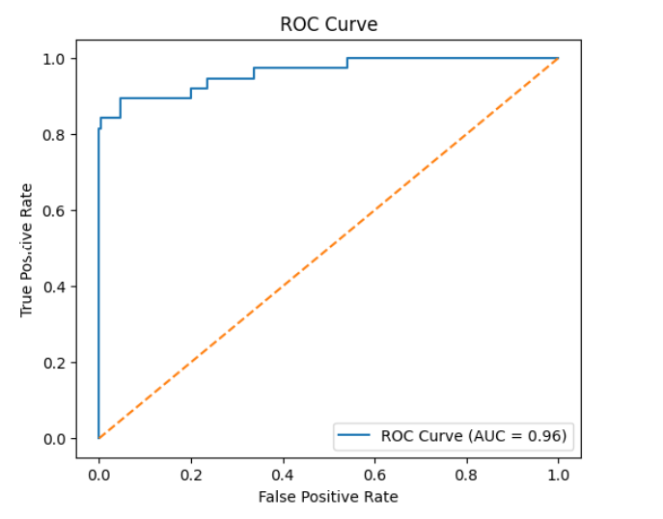
Figure 7.2: ROC Curve

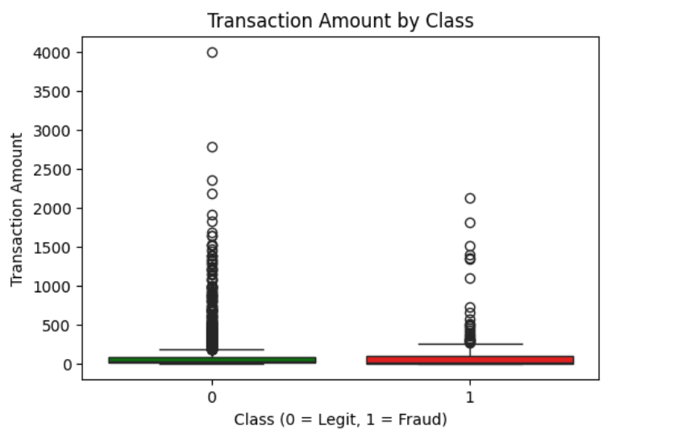

Figure 7.3: Transaction Amount by Class

7.2 DISCUSSION
This project successfully achieved its objective of detecting credit card fraud using supervised machine learning techniques by analysing historical transaction data. Through systematic preprocessing, feature analysis, and model evaluation, the study was able to identify meaningful patterns that distinguish fraudulent transactions from legitimate ones. The results clearly show that machine learning is an effective approach for handling the complexity and scale of modern financial transaction data.
Among the models implemented, Logistic Regression served as a useful baseline due to its simplicity and interpretability. However, it struggled to capture complex and non-linear relationships present in fraud patterns, especially in highly imbalanced data. Decision Trees provided better flexibility but were prone to overfitting. In contrast, ensemble-based models such as Random Forest and Gradient Boosting demonstrated superior performance by effectively capturing feature interactions and reducing variance, leading to more accurate fraud detection.
Feature preprocessing and selection played a crucial role in improving model performance. Normalization and scaling of transaction features helped stabilize model training, while imbalance-handling techniques improved the model’s ability to identify rare fraud cases. Feature importance analysis further highlighted that transaction-related attributes such as amount, time, and behavioural patterns significantly influenced fraud prediction.
Model evaluation using metrics like precision, recall, F1-score, and ROC-AUC confirmed that ensemble models outperformed simpler algorithms, particularly in terms of recall, which is critical for fraud detection. Visualization of confusion matrices and ROC curves provided additional insight into model behaviour, showing a better balance between detecting fraud and minimizing false positives.
Overall, this project demonstrates the practical usefulness of supervised machine learning for credit card fraud detection. Future improvements could include experimenting with advanced ensemble techniques, incorporating temporal transaction patterns, or combining supervised learning with anomaly detection methods. The findings of this study provide a strong foundation for building reliable and scalable fraud detection systems in real-world financial environments.

8. CREATIVITY & INNOVATION
Our project introduces a novel approach to crop yield prediction by integrating advanced machine learning techniques with innovative data preprocessing and model evaluation strategies. Unlike conventional yield estimation methods that rely on statistical models or limited feature sets, we implemented Random Forest Regression to analyses complex agricultural data patterns. This dual-model approach provided a comparative analysis of algorithm performance, allowing us to identify the most efficient model for predictive accuracy.
We incorporated feature engineering techniques to enhance model effectiveness, carefully selecting key agricultural parameters such as rainfall, temperature, soil type, and fertilizer usage. Additionally, our preprocessing pipeline included data normalization using MinMaxScaler to ensure numerical stability, along with missing value imputation to handle real-world data inconsistencies. The use of hyperparameter tuning methods such as Grid Search and Randomized Search further optimized model performance, ensuring a balance between computational efficiency and predictive accuracy.
A distinguishing aspect of our project is the visualization and interpretability of results. While many machine learning models provide only numerical outputs, we leveraged Power BI dashboards to present real-time, interactive visualizations of crop yield predictions. This user-friendly interface allows farmers, policymakers, and researchers to input region-specific parameters and receive insightful predictions, making the system not only technically sound but also practically applicable in agricultural decision-making.
Moreover, our project is designed with scalability and future adaptability in mind. The developed models can be extended to incorporate additional contextual factors such as weather forecasts, soil health indicators, and satellite imagery, ensuring a dynamic and evolving predictive system. By integrating these external variables, the model can provide more precise recommendations for optimized farming practices and resource allocation.
Overall, our project stands out for its technical depth, innovative model selection, robust evaluation metrics, and real-world usability. By combining machine learning advancements with practical visualization tools, we present a future-ready solution for precision agriculture, offering a data-driven approach to sustainable farming and food security.

9. COMMUNITY IMPACT
This project demonstrates creativity and innovation by applying supervised machine learning techniques to the challenging problem of credit card fraud detection, particularly focusing on highly imbalanced transaction data. Unlike traditional fraud detection systems that rely on fixed rules or manual verification, this project adopts a data-driven approach that learns directly from historical transaction patterns to identify fraudulent behaviour more effectively.
A key innovative aspect of the project is the comparative analysis of multiple machine learning models. Instead of relying on a single algorithm, models such as Logistic Regression, Decision Trees, Random Forest, and ensemble-based methods were implemented and evaluated side by side. This approach helped identify the most suitable model for fraud detection based on performance metrics rather than assumptions, highlighting the strengths of ensemble models in capturing complex fraud patterns.
The project also incorporates advanced data preprocessing and feature engineering techniques to enhance model performance. Transaction attributes were carefully analysed, scaled, and optimized to ensure numerical stability and better convergence during training. Special attention was given to handling class imbalance using appropriate techniques, which significantly improved the model’s ability to detect rare fraud cases an essential requirement in real-world financial systems.
Another innovative aspect lies in the interpretability and analysis of model results. Instead of treating machine learning models as black boxes, feature importance analysis and performance visualizations were used to understand which transaction characteristics most influenced fraud detection. This improves transparency and provides valuable insights for financial institutions to strengthen their fraud prevention strategies.
Furthermore, the project is designed with scalability and adaptability in mind. The methodology can be extended to include additional transaction features, behavioural patterns, or more advanced ensemble and hybrid learning techniques in the future. By combining robust machine learning models with careful evaluation and analysis, this project offers a practical, efficient, and future-ready approach to credit card fraud detection.

10. REFERENCES
[1] Vaishnavi T., et al. Detection of Credit Card Fraud Using Machine Learning. ICOFE, 2025. https://papers.ssrn.com/sol3/papers.cfm?abstract_id=5089121
[2] Dornadula, V. N., & Geetha, S. Credit Card Fraud Detection Using Machine Learning Algorithms. Procedia Computer Science, 2020. https://www.sciencedirect.com/science/article/pii/S187705092030065X
[3] Dal Pozzolo, A., et al. Adversarial Drift Detection in Credit Card Fraud Detection. IEEE TNNLS, 2015. https://ieeexplore.ieee.org/document/7280664
[4] Bhattacharyya, S., et al. Data Mining for Credit Card Fraud: A Comparative Study. Decision Support Systems, 2011. https://www.sciencedirect.com/science/article/pii/S0167923611000333
[5] More, R. S., Awati, C. J., & Suresh. Fraud Detection of Credit Cards Using Supervised ML Techniques. ICICCS, 2020. https://ieeexplore.ieee.org/search/searchresult.jsp?queryText=Fraud%20Detection%20of%20Credit%20Cards%20Using%20Supervised%20Machine%20Learning%20Techniques
[6] Alarfaj, F. K., et al. Machine Learning and Deep Learning Techniques for Credit Card Fraud Detection: A Review. IEEE Access, 2022.
https://ieeexplore.ieee.org/document/9693344
[7] Esenogho, E., et al. Neural Network Ensemble for Credit Card Fraud Detection. IEEE Access, 2022.
https://ieeexplore.ieee.org/document/9935678
[8] Ni, L., Zhang, J., & Wang, Y. Fraud Feature Boosting for Credit Card Fraud Detection. IEEE TCSS, 2024.
https://ieeexplore.ieee.org/document/10414642

